Name Of The Student | Garima Modiyani
Internship Project Topic | TCS iON RIO-210: Build a Classification Model for Drug Trials Dataset
Name of the Organization | TCS iON
Name of the Industry Mentor | jignasha royala
Name of the Institute | Amity University

Date | Day | Hours Spent
19-11-2025 | Day-39 | 4 hours 40 minutes
Activities done during the day:

Project Hands-on – Visualization the data By different type of charts

Link of the google drive google Colab file :-
https://colab.research.google.com/drive/1VQRq0l6oc9Uj4cOOqiuhkfS1JmpKr3fU?usp=sharing

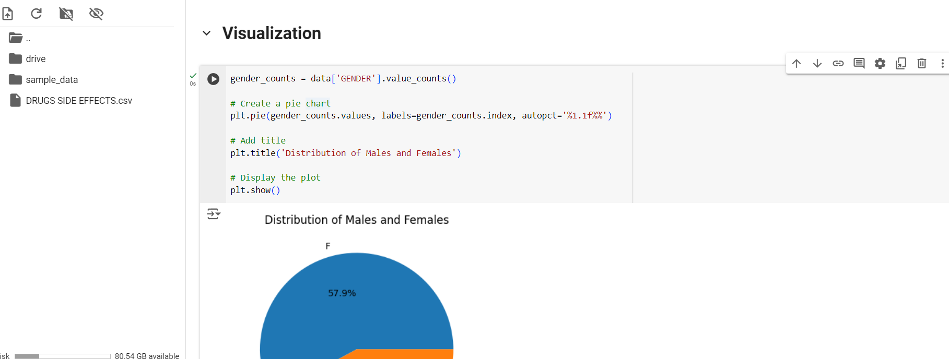

Check and create a chart of the age range of the male and female members

age_ranges = [0, 10, 20, 30, 40, 50, 60, 70, 80, 90, 100]

# Categorize the ages into the defined ranges
data['Age Range'] = pd.cut(data['AGE'], bins=age_ranges)

# Group the data by age range and gender, and count the number of occurrences
grouped_data = data.groupby(['Age Range', 'GENDER']).size().unstack()

# Set the figure size
plt.figure(figsize=(10, 6))

# Create a stacked bar plot
ax = grouped_data.plot(kind='bar', stacked=True)

# Add labels and title
plt.xlabel('Age Range')
plt.ylabel('Count')
plt.title('Number of Males and Females in Each Age Range')

# Display the plot
plt.show()

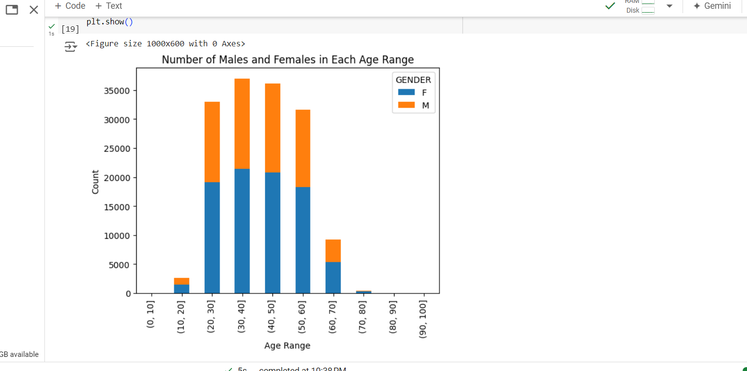

Check and create the chart of number of male, females in the data in age range

ata['Age Range'] = pd.cut(data['AGE'], bins=age_ranges).astype(str)

# Group the data by age range and gender, and count the number of occurrences
grouped_data = data.groupby(['Age Range', 'GENDER']).size().unstack()

# Create a stacked bar plot using Plotly
fig = go.Figure()

# Add bars for males and females in each age range
for col in grouped_data.columns:
fig.add_trace(go.Bar(x=grouped_data.index, y=grouped_data[col], name=col,
text=grouped_data[col], textposition='auto'))

# Update the layout of the figure
fig.update_layout(barmode='stack', xaxis_title='Age Range', yaxis_title='Count',
title='Number of Males and Females in Each Age Range')

# Display the plot
fig.show()

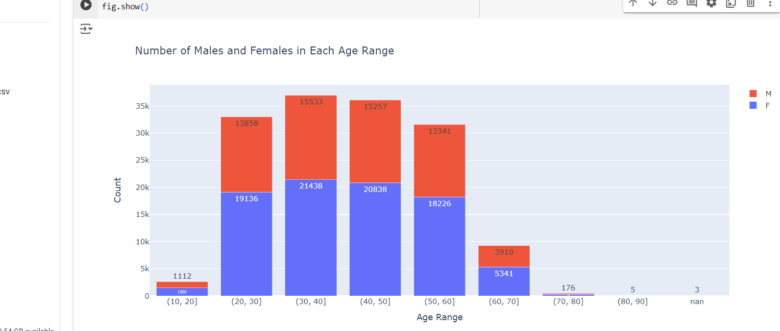

side_effect_counts = data['SIDE EFFECTS'].value_counts()
plt.bar(side_effect_counts.index, side_effect_counts.values)

# Add labels and title
plt.xlabel('Side Effect')
plt.ylabel('Count')
plt.title('Number of Side Effects')

# Rotate x-axis labels if needed
plt.xticks(rotation='vertical')

# Add number labels on top of each bar
for i, v in enumerate(side_effect_counts.values):
plt.text(i, v, str(v), ha='center', va='bottom')

# Display the plot
plt.show()

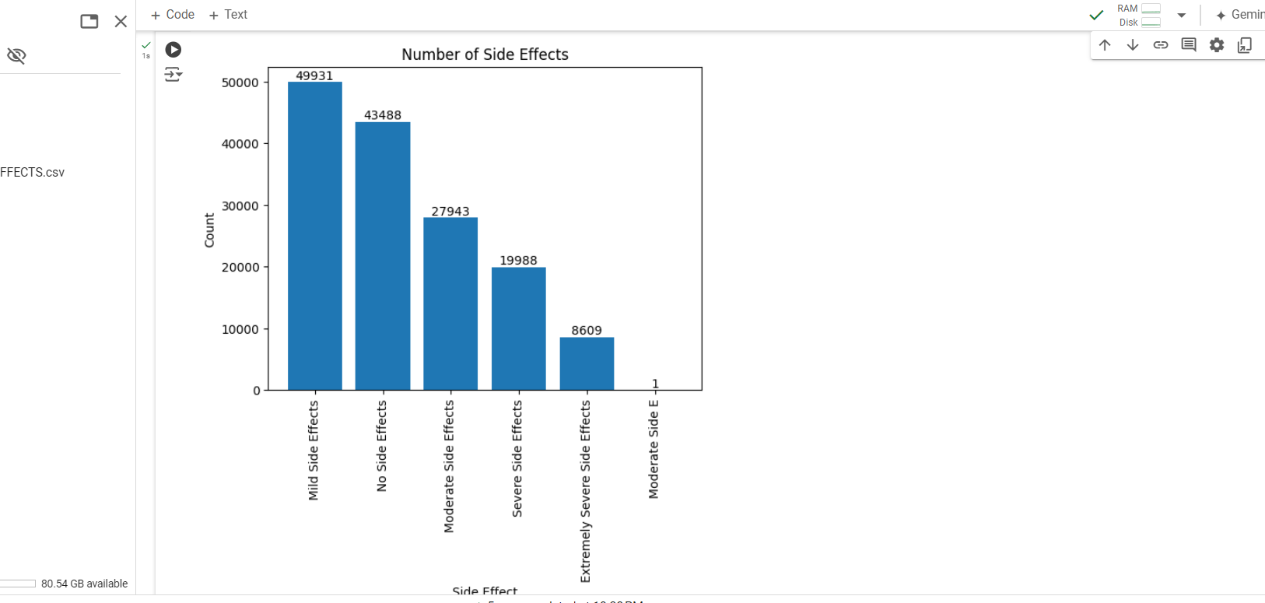

race_counts = data['RACE'].value_counts()
fig = go.Figure(data=[go.Bar(x=race_counts.index, y=race_counts.values,
text=race_counts.values, textposition='auto')])

# Add labels and title
fig.update_layout(xaxis_title='Race', yaxis_title='Count', title='Number of People by Race')

# Rotate x-axis labels if needed
fig.update_layout(xaxis_tickangle=-45)

# Display the plot
fig.show()

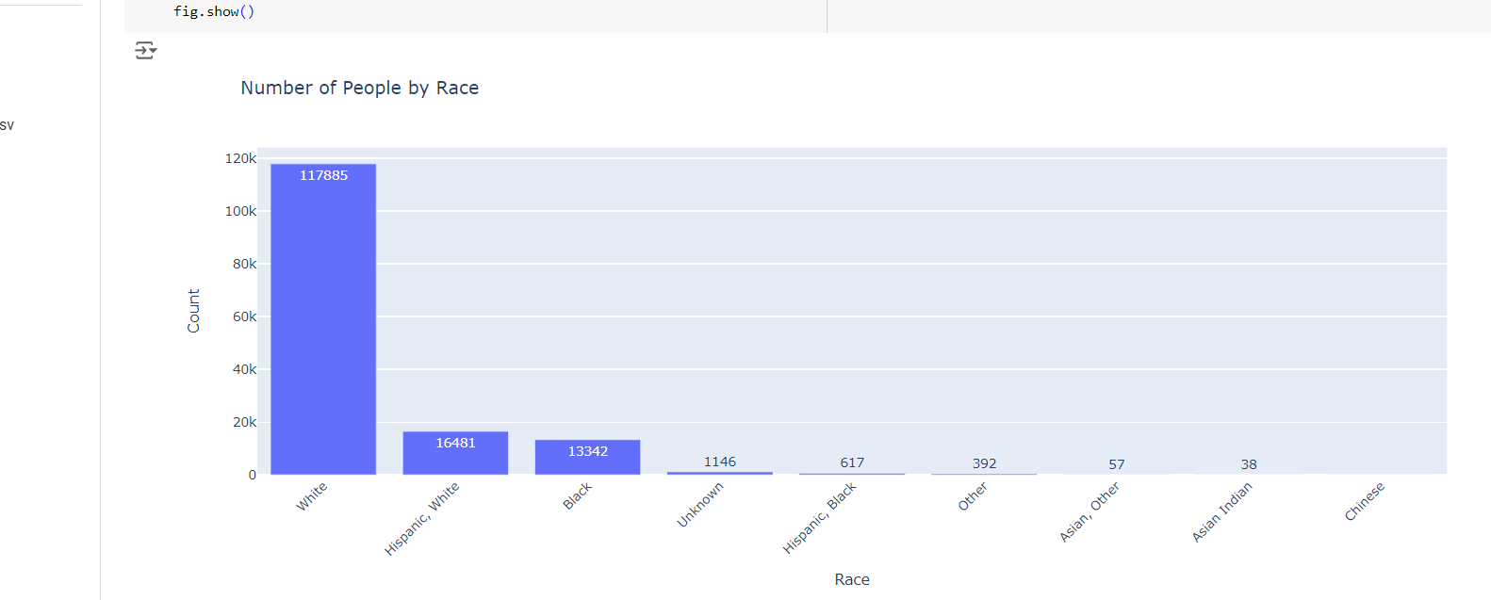
# Define the side effect categories
side_effect_categories = ['Mild Side Effects', 'No Side Effects', 'Moderate Side Effects', 'Severe Side Effects', 'Extremely Severe Side Effects']

# Iterate over each side effect category
for category in side_effect_categories:
# Filter the data for the specific side effect category
filtered_data = data[data['SIDE EFFECTS'] == category]

# Count the occurrences of each drug name
drug_counts = filtered_data['DRUG NAME'].value_counts()

# Sort the drug names based on the counts
sorted_drugs = drug_counts.sort_values(ascending=False)

# Select the top 20 drug names
top_20_drugs = sorted_drugs.head(20)

# Create a bar plot to display the top 20 drug names
plt.figure(figsize=(15, 6))
plt.bar(top_20_drugs.index, top_20_drugs.values)

# Add labels and title
plt.xlabel('Drug Name')
plt.ylabel('Count')
plt.title(f'Top 20 Drug Names with {category}')

# Rotate x-axis labels if needed
plt.xticks(rotation='vertical')

# Add count values on top of each bar
for i, value in enumerate(top_20_drugs.values):
plt.text(i, value, str(value), ha='center', va='bottom')

# Display the plot
plt.show()

